- Program ID : VM002MA1

- Display Layout
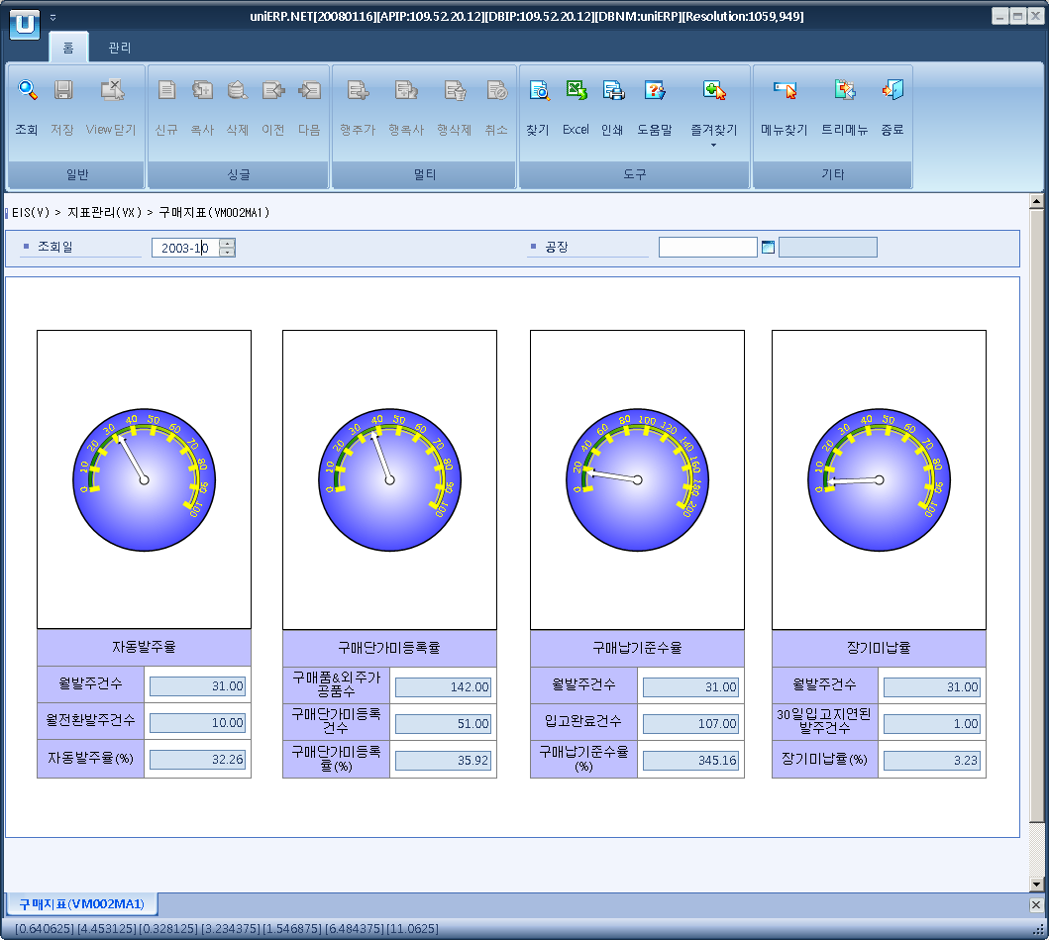

- Event flow
- Click Query button
- OnFncQuery -> DbQuery -> DataChange
- Display Unit combo change
- uniCombo1_ValueChanged -> DataChange

- SQL Statements
- Auto P/O rate
SELECT SUM(VM0020T.TOT_CNT),
CASE WHEN SUM(VM0020T.TOT_CNT) - SUM(VM0020T.NOR_CNT) <= 0 THEN 0
ELSE SUM(VM0020T.TOT_CNT) - SUM(VM0020T.NOR_CNT)
END,
SUM(VM0020T.NOR_CNT), SUM(VM0020T.RATE)
FROM VM0020T
WHERE VM0020T.SP_ID = @strSpId
AND VM0020T.YYYYMM = @strYYYYMM
AND VM0020T.INDEX_CD = 'M01'

- Rate of not registration purchase unit price
SELECT SUM(VM0020T.TOT_CNT),
CASE WHEN SUM(VM0020T.TOT_CNT) - SUM(VM0020T.NOR_CNT) <= 0 THEN 0
ELSE SUM(VM0020T.TOT_CNT) - SUM(VM0020T.NOR_CNT)
END,
SUM(VM0020T.NOR_CNT), SUM(VM0020T.RATE)
FROM VM0020T
WHERE VM0020T.SP_ID = @strSpId
AND VM0020T.YYYYMM = @strYYYYMM
AND VM0020T.INDEX_CD = 'M02'

- Purchase on time delivery ratio
SELECT SUM(VM0020T.TOT_CNT),
CASE WHEN SUM(VM0020T.TOT_CNT) - SUM(VM0020T.NOR_CNT) <= 0 THEN 0
ELSE SUM(VM0020T.TOT_CNT) - SUM(VM0020T.NOR_CNT)
END,
SUM(VM0020T.NOR_CNT), SUM(VM0020T.RATE)
FROM VM0020T
WHERE VM0020T.SP_ID = @strSpId
AND VM0020T.YYYYMM = @strYYYYMM
AND VM0020T.INDEX_CD = 'M03'

- Long unreceipt rate
SELECT SUM(VM0020T.TOT_CNT),
CASE WHEN SUM(VM0020T.TOT_CNT) - SUM(VM0020T.NOR_CNT) <= 0 THEN 0
ELSE SUM(VM0020T.TOT_CNT) - SUM(VM0020T.NOR_CNT)
END,
SUM(VM0020T.NOR_CNT), SUM(VM0020T.RATE)
FROM VM0020T
WHERE VM0020T.SP_ID = @strSpId
AND VM0020T.YYYYMM = @strYYYYMM
AND VM0020T.INDEX_CD = 'M04'

